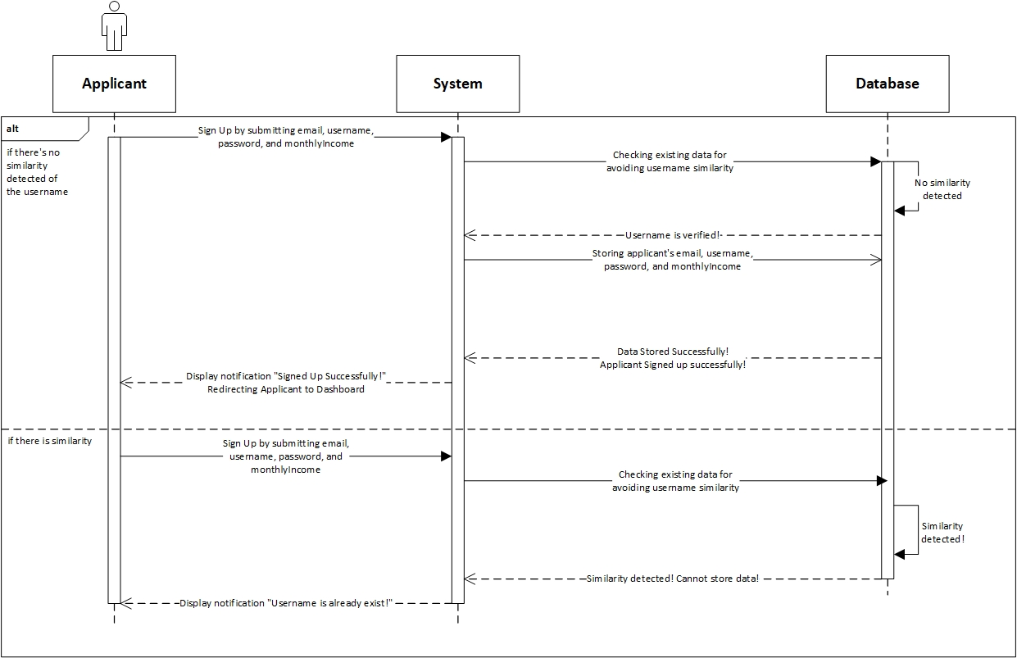

|  |  |
| --- | --- |
| **Cross References** | **Sign up Applicant** |
| Operation | Sign up with email, username, password, and monthlyIncome |
| Responsible | To be registered in system and able to access the main page |
| Pre-conditions | * Email must be available * Username must be available * Password must be available * MonthlyIncome must be available |
| Post-conditions | * Username is verified (no similarity detected) * Registered in System * Display dashboard |
| **Cross References** | **Sign up Applicant** |
| Operation | Sign up with email, username, password, and monthlyIncome |
| Responsible | To be registered in system and able to access the main page |
| Pre-conditions | * Email must be available * Username must be available * Password must be available * MonthlyIncome must be available |
| Post-conditions | * Username is not verified (Similarity detected, already existed in system) * Applicant must re-enter new username. |

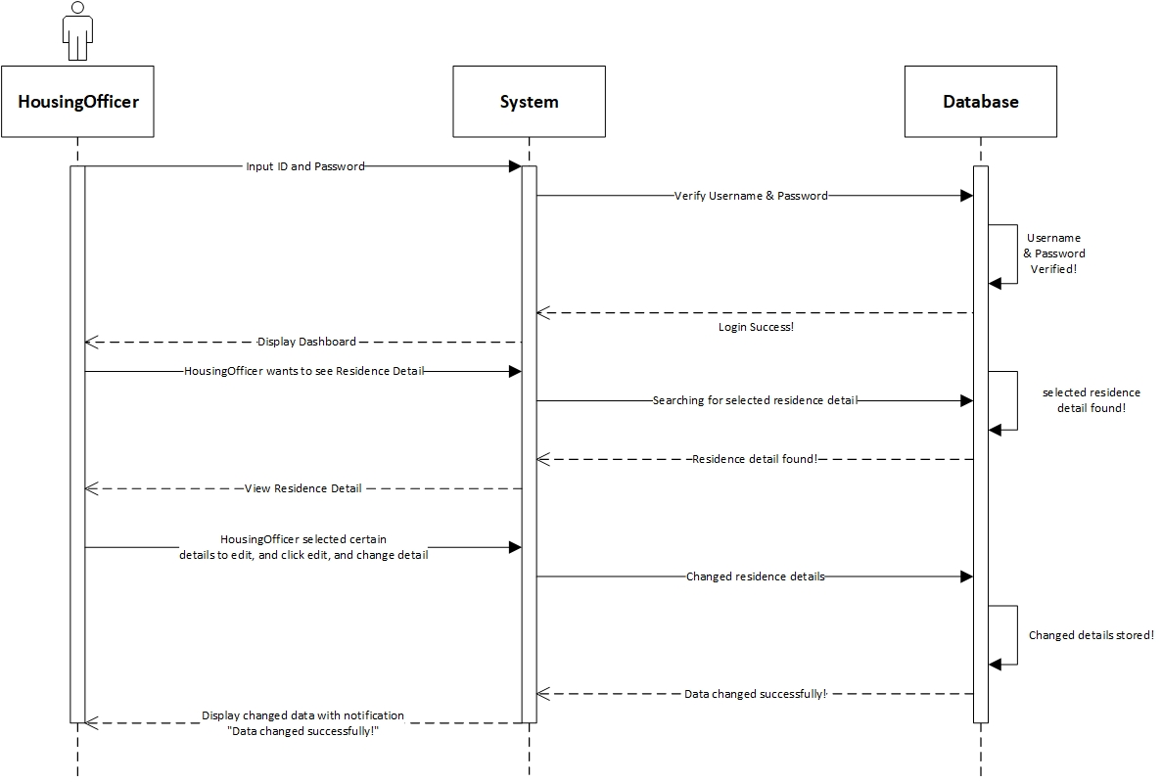

|  |  |
| --- | --- |
| **Cross References** | **Edit Residence Detail** |
| Operation | Login with username and password |
| Responsible | To get access to view the applications |
| Pre-conditions | * Username must be available * Password must be available |
| Post-conditions | * Username is matched * Password must be match based on user’s password input * Display dashboard |
| **Cross References** | **Edit Residence Detail** |
| Operation | Edit residenceID, address, numUnits, sizePerUnit, monthlyRental |
| Responsible | To change certain Residence Detail |
| Pre-conditions | We will need **one of** or **all of** the details below:   * Email must be available * Username must be available * Password must be available * MonthlyIncome must be available |
| Post-conditions | Residence Detail changed successfully |

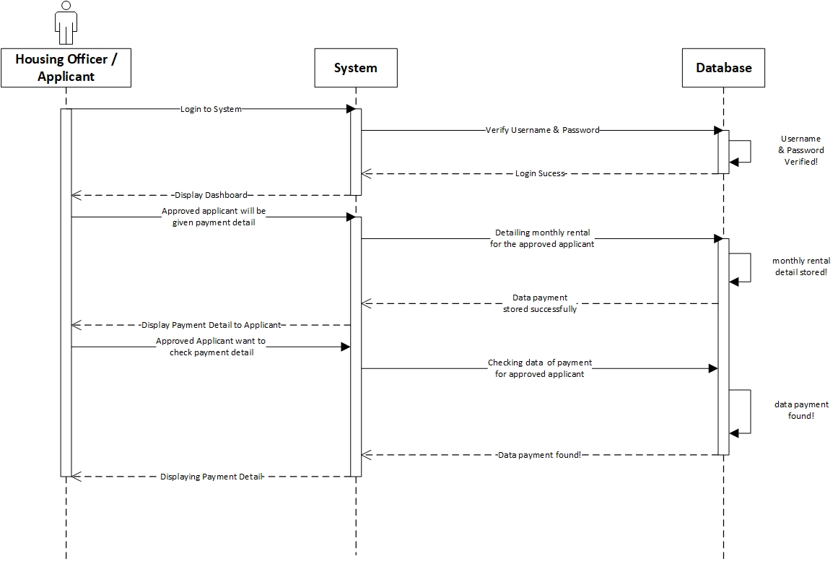

|  |  |
| --- | --- |
| **Cross References** | **Payment Detail** |
| Operation | Login with username and password |
| Responsible | To get access to view the applications |
| Pre-conditions | * Username must be available * Password must be available |
| Post-conditions | * Username is matched * Password must be match based on user’s password input * Display dashboard |
| **Cross References** | **Payment Detail** |
| Operation | Entering Payment Detail (payment rent) |
| Responsible | To store payment detail of applicants monthly rent |
| Pre-conditions | * HousingOfficer must already have the exact amount of monthly rent to be entered * Applicants has already live in the residence |
| Post-conditions | Payment Detail stored Successfully, and HousingOfficer can preview the result immediately. |

|  |  |
| --- | --- |
| **Cross References** | **Payment Detail** |
| Operation | View Payment Detail |
| Responsible | To see applicants amount of monthly rent payment |
| Pre-conditions | * HousingOfficer must already enter the payment detail * Applicants has already live in the residence |
| Post-conditions | Applicants can see exactly amount of payment rent they need to pay. |

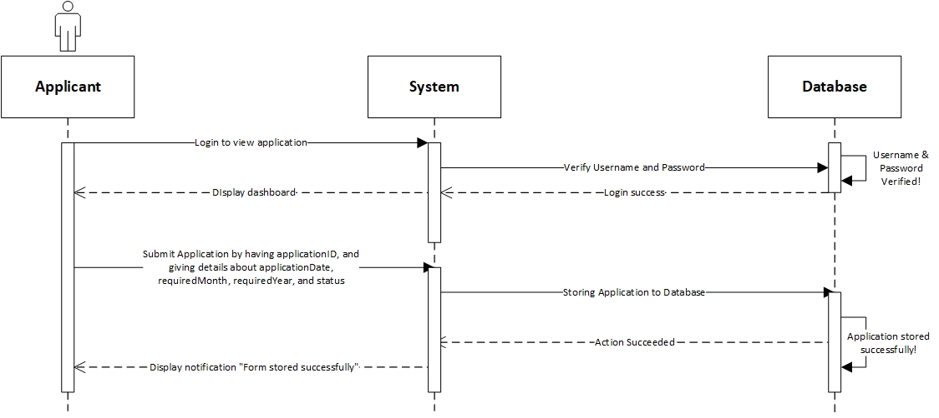

|  |  |
| --- | --- |
| **Cross References** | **Submit Application** |
| Operation | Login with username and password |
| Responsible | To get access to view the applications |
| Pre-conditions | * Username must be available * Password must be available |
| Post-conditions | * Username is matched * Password must be match based on user’s password input * Display dashboard |
| **Cross References** | **Submit Application** |
| Operation | Submit applicationID, applicationDate, requiredMonth, requiredYear, and status |
| Responsible | To submit applicant’s application to the database |
| Pre-conditions | We will need **all of** the details below:   * applicationID will be given by system automatically * applicationDate must be available * requiredMonth must be available * requiredYear must be available * status will be given by system automatically |
| Post-conditions | Application will be stored successfully, and will be on waiting list for the approval & arrangement by HousingOfficer. |

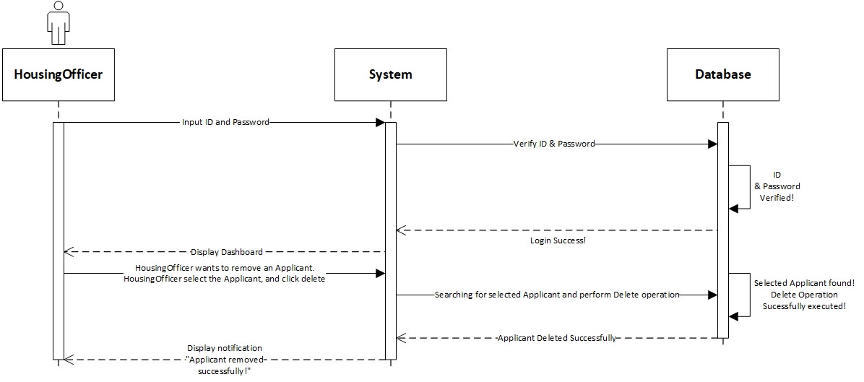

|  |  |
| --- | --- |
| **Cross References** | **Delete Applicant** |
| Operation | Login with ID and username |
| Responsible | To access dashboard, and delete applicant |
| Pre-conditions | * Username must be available * Password must be available |
| Post-conditions | * Username is matched * Password must be match based on user’s password input * Display dashboard |
| **Cross References** | **Delete Applicant** |
| Operation | Delete Applicant |
| Responsible | To remove an applicant |
| Pre-conditions | The applicant object must be available, and the applicant is no longer in place (checkout) |
| Post-conditions | Applicant object will be removed successfully/ |